Essay
For a long time, I have been thinking about the subject of my essay –coaching. I wanted to share how coaching has influenced my life, how it has brought positive emotions, harmony and joy into my life and how it has radically changed me.
Instead, I decided to share a discovery that I made during the coaching sessions and self-coaching. Guided by the basic coaching principles (customer is fine, judgement-free, having faith in and follow the customer) I found that we divide people into three categories: visitor, complainant and client. At the same time, only 10% of people are clients, those who have high level of awareness and formed goals, and the remaining 90% are visitors and complainants! Consequently, firstly, the judgement appears as we immediately start to label a person as a client, visitor or complainant. Secondly, a serious loss of customers who want to explore the problems happens, but the goals and the technology of coaching is perfectly suited for solving the problems.
Finally, combining the knowledge of psychology and coaching I have discovered a tool that allows working with everyone, a tool that does not contradict any principles of coaching and uses the power of its technology. The name of the tool is COMPASS.

COMPASS
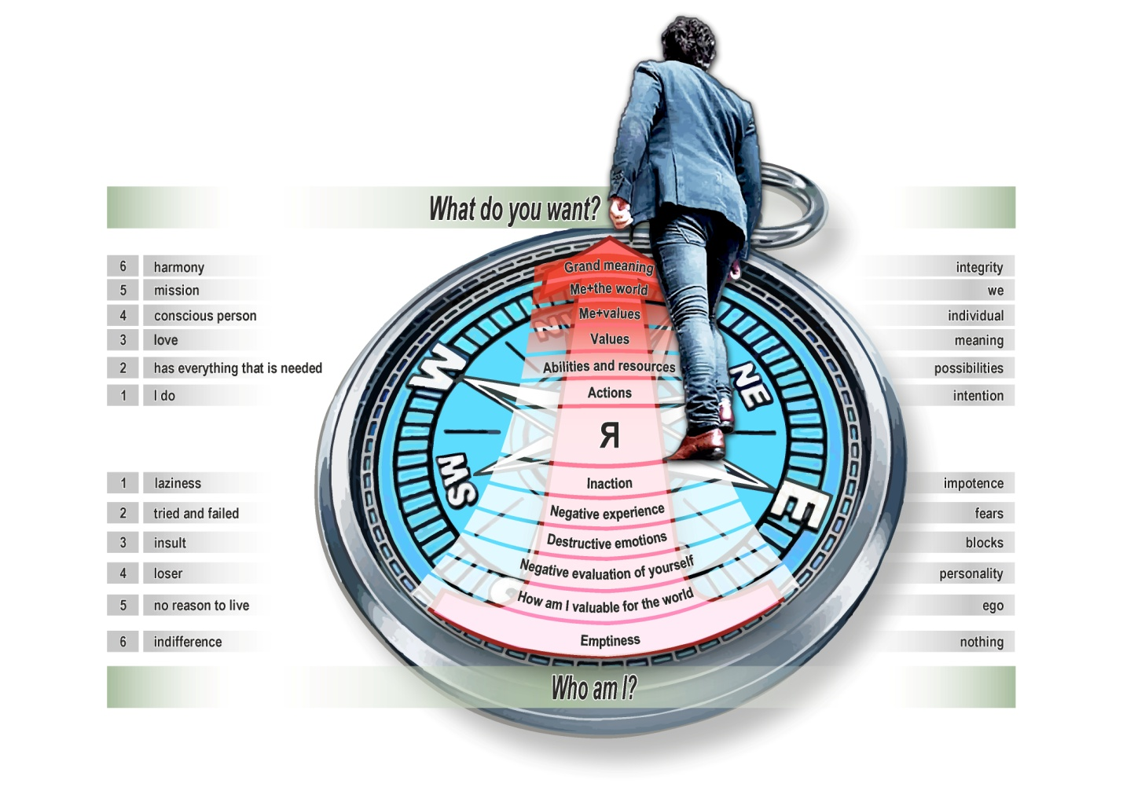

We work with the top-pyramid according to the classical system of coaching, there is nothing innovative. Therefore, I will focus on the bottom-pyramid.
Technology and mechanism of work
- Always follow a customer. If a customer is positive, we also try to stay positive. If a customer is being negative, we try to follow him anyway in staying negative and trust ourselves and a customer. It is very important to do not push the customers and follow their emotions all the way until they explore every emotional aspect of themselves.
- Similarities between the top and the bottom of pyramids. Each level in the conditionally positive pyramid (awareness, vision, inspiration and joy) corresponds to the level in the conditionally negative pyramid (fear, block, powerlessness, pain). The lower a person goes down in the pyramid of negativity, the higher level this person reaches with the question “What is the positive intention of the logical level?”. Furthermore, from there it is possible to go even farther in the pyramid of positivity and overlook all of the completed levels.
- Ecology. Before using the COMPASS, it is important to explain the instrument to the customer and obtain his consent and clear intention. Make it clear that this tool explores both positive and negative levels, the final choice is always up to the customer and he always has the right to say stop.
- Choice. Direct communication between the coach and the customer is very important. The coach must always be in contact with the customer, giving him/her a choice to move down or up. It is very important to remember that the choice is always up to the customer!
- Report. It is crucial to keep a powerful report when working with a customer. I do not recommend to going on the lower levels without the necessary guarantee from a customer.
- Limit. Regardless of level, if a client came to a standstill we would always try to move him towards positivity. We should use questions like “Ask yourself, if this state had a positive intention, what would have been its meaning?”, “If this state was given to you to realize something very valuable and important, what would it be?” and so on.
- Aspects. After the transfer to the upper level the discrepancy is noticeable. For example, the customer was on the bottom-fifth level, then went up to the third, or the customer was on the bottom-second level and went up to the forth. In such cases, it is necessary to make sure that the customer did not deceive him/herself and consistently investigated the levels above or below the expected level of transfer. That is, in the first case we check the levels above the third, and in the second case we check the levels below the fourth. But it is not crucial.
- Preparation for work. The physiological aspect is extremely important. If a customer is ready to examine the lower levels (3d and below) he/she needs a physical training. A customer must have a good sleep, be emotionally stable, preferably with at least one day of rest ahead of him/her. There should be no parties, alcohol or exhausting flights after the session. A customer is supposed to rest, preferably alone at least for some time after the session. Walking in the woods or in the park, listening to a soft music or having a relaxing hobby are great examples of relaxation.
- Security. At the end of the meeting a customer receives a huge insider knowledge and a very powerful release of endorphins, which gives him/her a euphoria and a burst of energy. But during the meeting a customers do not spend less energy, because they experience a stressful situation that causes a protective reaction of the body. Therefore, it is important to make sure that a person does not suffer from hypertension, migraines, ulcers and other diseases, because emotional experiences can provoke an exacerbation.
- Differences. Usually, coaches do not let the customers to go into the negativity by using periphrasis. Whereas COMPASS coaches are supposed to follow the customers into the negative area, in order to find the source of negative emotions, which helps to turn customers’ emotions into positive direction. If we compare with psychology, they usually investigate customer’s negativity and return to the neutral state, not into positivity, which usually entails a depressed state of the client and misunderstanding of where to move forward.
This tool is still in the stage of testing but it’s already getting clear that it’s 100% effective.
Recommendations for use
Complainants. It is not recommended to go below the second level with this type of customers until there is a powerful report. If the periphrasis does not work and a customer still goes into negativity, a coach can gently explore a customer and with his/her consent – turn to the positivity.
Customers, for whom the methods of classical coaching or psychotherapy do not work. Here coaches can use 100% of their potential. Usually, such customers have a strong intention to deal with both top and bottom levels, most of them used to work in areas of either coaching or psychotherapy.
Customers who want to explore the origins of fear and negative emotions. With such customers it is necessary to sign a contract for a purposeful study of the lower levels, to monitor customer’s emotional state and to work gently.
Philosophy

I love people very much. It has always been painful for me to see how another people suffer and it made me more compassionate. For a long time, I have been searching for a way how to make other people happy and how to provide maximum assistance as soon as possible.
While I was creating this tool, I used primarily the ideas of freedom and identifying everyone as a personality. A person, who is free from the MATRIX programs, is always capable of making a choice, of becoming a creator of life and of being free from prejudiced, authorities and other people’s truths.
When people explore different areas of life they often stray from the path, they don’t understand what is going on and as a result they do not see where to move forward. Compass is a tool that allows to navigate in time and space, find yourself and see the way for moving forward.
Compass is a model of a person. The circle is a consciousness, interaction, struggle and unity of two variables, as a sign of Yin and Yang. The top of the Compass gives inspiration and vision where to go further. The bottom of the Compass is energy. Energy is locked by our consciousness and it is not accidental. It is all about motivation. If a person is guided by the ideas of power, self-importance and selfishness, then after finally getting this energy ahead of time it will simply tear the person apart and hurt other people. The Compass allows people to show the way and to give the energy (when the goal is finally set) which is blocked in fears, negative emotions, feelings of loneliness and powerlessness. We can compare the Compass to a rocket. The top of the pyramid is its dome, the bottom – its engines. It is possible to show the way to a person, but if there is no energy in the engines a rocket will never fly.
Consciousness is a circle of the Compass and the direction of the arrows is where the attention is directed. The truth is that no matter where people go, to the bottom or up, it is important to control the attention. Even if you fall to the bottom it is not the end, on the contrary, the truth might be revealed and you will find a new beginning. However, if a person has reached the top of the pyramid, he/she may not only realize the truth, but also to overlook the bottom and realize what was stopping him/her all this time. It is possible to see not only an obstacle that must be destroyed, but also a value of the negative experiences. All of it allows you to look at yourself and your life, to find the meaning of everything that is going on. Moreover, it is important to sincerely thank life and forgive the people around you, and most importantly – forgive yourself. It gives a real freedom, a freedom to be yourself, to choose the path that is truly yours. To generate ides and to find the inner core and happiness.

Dear Marilyn Atkinson, your opinion about the Compass is very important to me. I hope that it will be useful not only to ordinary people, but also for other coaches, because coaching is all about the development and Compass allows to gently explore areas that might be interesting to coaches, psychologists, people, who are oriented to develop personalities and everyone, who lives by the ides of awareness and self-knowledge
Instagram: alushekov
Skype: lushekov alex
e-mail: alushekov@gmail.com
Alexey Lushсhekov

.

